

Medical Radiation Practice Board of Australia

Registrant data

Reporting period: 1 April 2018 – 30 June 2018

Table of contents
Introduction 3
Principal place of practice 4
1. Registration type 4
2. Divisions 5
Age group 6
3. Registration type and subtype 6
4. Divisions 7
Gender 8
5. Registration type 8
6. Percentage 8

Introduction
The role of the Medical Radiation Practice Board of Australia (the Board) is to:
- register medical radiation practitioners and students
- develop standards, codes and guidelines for the medical radiation profession
- investigate notifications and complaints
- where necessary, conduct panel hearings and refer serious matters to Tribunal hearings
- oversee the assessment of overseas trained practitioners who wish to practise in Australia, and
- approve accreditation standards and accredited courses of study.
The Board’s functions are supported by the Australian Health Practitioner Regulation Agency (AHPRA). For information about legislation governing our operations see About AHPRA at www.ahpra.gov.au/About-AHPRA/What-We-Do/Legislation.aspx.
The Board has analysed its registration data and produced a number of statistical breakdowns about registrants to share with the profession and community. The Board shares these breakdowns regularly.
For more information on medical radiation practitioner registration, please see the Board’s website: www.medicalradiationpracticeboard.gov.au/Registration.aspx

Principal place of practice
- Registration type
  - Registration type and subtype by principal place of practice
Registration type | Subtype | ACT | NSW | NT | QLD | SA | TAS | VIC | WA | No PPP | Total
General |  | 262 | 5,114 | 99 | 3,243 | 1,216 | 318 | 3,761 | 1,338 | 250 | 15,601
Provisional |  | 4 | 231 | 11 | 56 | 5 | 3 | 102 | 5 |  | 417
Limited | Supervised practice |  |  |  |  | 1 |  |  |  |  | 1
Non-practising |  | 6 | 68 | 1 | 22 | 15 | 4 | 76 | 16 | 30 | 238
Total |  | 272 | 5,413 | 111 | 3,321 | 1,237 | 325 | 3,939 | 1,359 | 280 | 16,257

  - Registration type by principal place of practice percentages

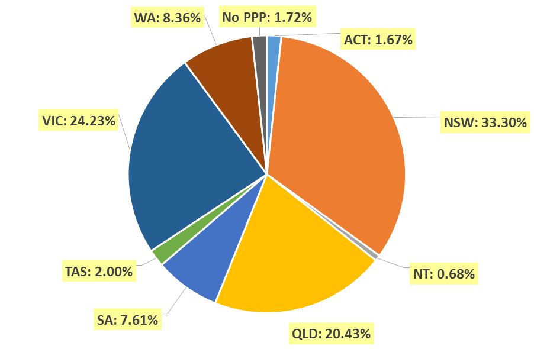

- Divisions
  - By area of division
Divisions | ACT | NSW | NT | QLD | SA | TAS | VIC | WA | No PPP | Total
Diagnostic Radiographer | 193 | 4,157 | 98 | 2,595 | 990 | 242 | 2,962 | 1,106 | 231 | 12,574
Diagnostic Radiographer and Nuclear Medicine Technologist |  | 2 |  | 10 | 1 | 1 | 1 | 2 |  | 17
Diagnostic Radiographer and Radiation Therapist |  |  |  | 1 |  |  | 1 |  |  | 2
Nuclear Medicine Technologist | 24 | 454 | 2 | 180 | 85 | 17 | 351 | 67 | 17 | 1,197
Radiation Therapist | 55 | 800 | 11 | 535 | 161 | 65 | 624 | 184 | 32 | 2,467
Total | 272 | 5,413 | 111 | 3,321 | 1,237 | 325 | 3,939 | 1,359 | 280 | 16,257

Age group
- Registration type and subtype
  - Registration by age group
Age Group | General | Provisional | Limited |  | Non-practising | Total
Age Group | General | Provisional | Post graduate training or supervised practice | Supervised Practice | Non-practising | Total
U - 25 | 1,203 | 263 |  |  | 2 | 1,468
25 - 29 | 2,988 | 95 |  |  | 39 | 3,122
30 - 34 | 2,891 | 29 |  |  | 44 | 2,964
35 - 39 | 2,154 | 14 |  |  | 47 | 2,215
40 - 44 | 1,649 | 9 |  |  | 40 | 1,698
45 - 49 | 1,390 | 5 |  |  | 15 | 1,410
50 - 54 | 1,062 | 1 |  |  | 13 | 1,076
55 - 59 | 1,083 | 1 |  |  | 16 | 1,100
60 - 64 | 795 |  |  | 1 | 11 | 807
65 - 69 | 310 |  |  |  | 6 | 316
70 - 74 | 61 |  |  |  | 4 | 65
75 - 79 | 14 |  |  |  | 1 | 15
80+ | 1 |  |  |  |  | 1
Total | 15,601 | 417 |  | 1 | 238 | 16,257

- Divisions
  - Divisions by age group
Age Group | Diagnostic Radiographer | Diagnostic Radiographer and Nuclear Medicine Technologist | Diagnostic Radiographer and Radiation Therapist | Nuclear Medicine Technologist | Radiation Therapist | Total
U - 25 | 1,082 |  |  | 153 | 233 | 1,468
25 - 29 | 2,394 | 1 |  | 256 | 471 | 3,122
30 - 34 | 2,171 |  |  | 226 | 567 | 2,964
35 - 39 | 1,639 | 4 |  | 183 | 389 | 2,215
40 - 44 | 1,289 | 3 | 1 | 127 | 278 | 1,698
45 - 49 | 1,098 | 5 | 1 | 101 | 205 | 1,410
50 - 54 | 904 | 2 |  | 57 | 113 | 1,076
55 - 59 | 927 | 2 |  | 43 | 128 | 1,100
60 - 64 | 698 |  |  | 40 | 69 | 807
65 - 69 | 293 |  |  | 10 | 13 | 316
70 - 74 | 63 |  |  | 1 | 1 | 65
75 - 79 | 15 |  |  |  |  | 15
80+ | 1 |  |  |  |  | 1
Total | 12,574 | 17 | 2 | 1,197 | 2,467 | 16,257

  - Registration by age group

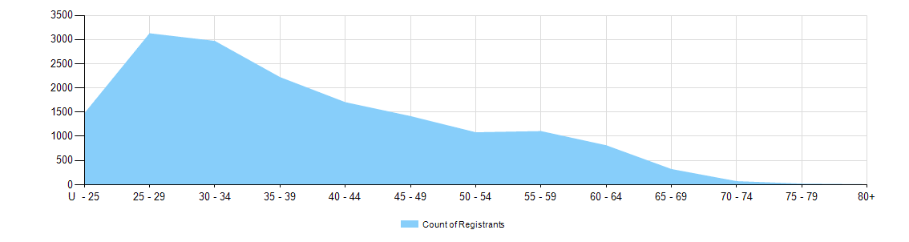

Gender
- Registration type
  - Registration type by gender
Gender | Registration Type | Subtype | ACT | NSW | NT | QLD | SA | TAS | VIC | WA | No PPP | Total
Female | General |  | 172 | 3,453 | 62 | 2,177 | 898 | 222 | 2,528 | 921 | 182 | 10,615
Female | Provisional |  |  | 153 | 7 | 35 | 3 | 2 | 73 | 5 |  | 278
Female | Limited | Supervised practice
Female | Non-practising |  | 6 | 47 | 1 | 18 | 13 | 4 | 55 | 14 | 24 | 182
Total Female |  |  | 178 | 3,653 | 70 | 2,230 | 914 | 228 | 2,656 | 940 | 206 | 11,075
Male | General |  | 90 | 1,661 | 37 | 1,066 | 318 | 96 | 1,233 | 417 | 68 | 4,986
Male | Provisional |  | 4 | 78 | 4 | 21 | 2 | 1 | 29 |  |  | 139
Male | Limited | Supervised practice |  |  |  |  | 1 |  |  |  |  | 1
Male | Non-practising |  |  | 21 |  | 4 | 2 |  | 21 | 2 | 6 | 56
Total Male |  |  | 94 | 1,760 | 41 | 1,091 | 323 | 97 | 1,283 | 419 | 74 | 5,182
Total |  |  | 272 | 5,413 | 111 | 3,321 | 1,237 | 325 | 3,939 | 1,359 | 280 | 16,257

- Percentage
  - Registration by gender percentages
Gender | ACT | NSW | NT | QLD | SA | TAS | VIC | WA | No PPP | Total
Female | 65.4% | 67.5% | 63.1% | 67.1% | 73.9% | 70.2% | 67.4% | 69.2% | 73.6% | 68.1%
Male | 34.6% | 32.5% | 36.9% | 32.9% | 26.1% | 29.8% | 32.6% | 30.8% | 26.4% | 31.9%

