

Medical Radiation Practice Board of Australia

Registrant data

Reporting period: 1 July 2018 – 30 September 2018

Table of contents
Introduction 3
Principal place of practice 4
1. Registration type 4
2. Divisions 5
Age group 6
3. Registration type and subtype 6
4. Divisions 7
Gender 8
5. Registration type 8
6. Percentage 8

Introduction
The role of the Medical Radiation Practice Board of Australia (the Board) is to:
- register medical radiation practitioners and students
- develop standards, codes and guidelines for the medical radiation profession
- investigate notifications and complaints
- where necessary, conduct panel hearings and refer serious matters to Tribunal hearings
- oversee the assessment of overseas trained practitioners who wish to practise in Australia, and
- approve accreditation standards and accredited courses of study.
The Board’s functions are supported by the Australian Health Practitioner Regulation Agency (AHPRA). For information about legislation governing our operations see About AHPRA at www.ahpra.gov.au/About-AHPRA/What-We-Do/Legislation.aspx.
The Board has analysed its registration data and produced a number of statistical breakdowns about registrants to share with the profession and community. The Board shares these breakdowns regularly.
For more information on medical radiation practitioner registration, please see the Board’s website: www.medicalradiationpracticeboard.gov.au/Registration.aspx

Principal place of practice
- Registration type
  - Registration type and subtype by principal place of practice
Registration type | Subtype | ACT | NSW | NT | QLD | SA | TAS | VIC | WA | No PPP | Total
General |  | 263 | 5,130 | 103 | 3,258 | 1,219 | 322 | 3,781 | 1,338 | 262 | 15,676
Provisional |  | 4 | 226 | 11 | 58 | 4 | 3 | 100 | 5 |  | 411
Limited | Supervised practice |  |  |  |  | 1 |  |  |  |  | 1
Non-practising |  | 7 | 67 | 1 | 22 | 14 | 4 | 76 | 17 | 30 | 238
Total |  | 274 | 5,423 | 115 | 3,338 | 1,238 | 329 | 3,957 | 1,360 | 292 | 16,326

  - Registration type by principal place of practice percentages

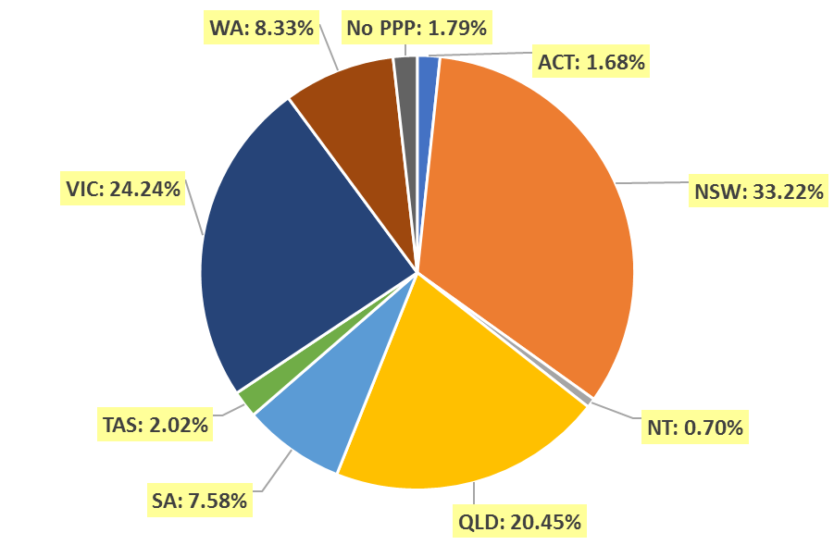

- Divisions
  - By area of division
Divisions | ACT | NSW | NT | QLD | SA | TAS | VIC | WA | No PPP | Total
Diagnostic Radiographer | 195 | 4,164 | 101 | 2,611 | 990 | 244 | 2,966 | 1,104 | 243 | 12,618
Diagnostic Radiographer and Nuclear Medicine Technologist |  | 2 |  | 10 | 1 | 1 | 1 | 2 |  | 17
Diagnostic Radiographer and Radiation Therapist |  |  |  | 1 |  |  | 1 |  |  | 2
Nuclear Medicine Technologist | 25 | 456 | 3 | 181 | 86 | 16 | 349 | 68 | 15 | 1,199
Radiation Therapist | 54 | 801 | 11 | 535 | 161 | 68 | 640 | 186 | 34 | 2,490
Total | 274 | 5,423 | 115 | 3,338 | 1,238 | 329 | 3,957 | 1,360 | 292 | 16,326

Age group
- Registration type and subtype
  - Registration by age group
Age Group | General | Provisional | Limited |  | Non-practising | Total
Age Group | General | Provisional | Post graduate training or supervised practice | Supervised Practice | Non-practising | Total
U - 25 | 1,091 | 250 |  |  | 2 | 1,343
25 - 29 | 3,019 | 98 |  |  | 39 | 3,156
30 - 34 | 2,874 | 30 |  |  | 43 | 2,947
35 - 39 | 2,234 | 15 |  |  | 47 | 2,296
40 - 44 | 1,648 | 10 |  |  | 38 | 1,696
45 - 49 | 1,416 | 5 |  |  | 19 | 1,440
50 - 54 | 1,076 | 1 |  |  | 12 | 1,089
55 - 59 | 1,086 | 2 |  |  | 14 | 1,102
60 - 64 | 827 |  |  | 1 | 13 | 841
65 - 69 | 322 |  |  |  | 6 | 328
70 - 74 | 67 |  |  |  | 4 | 71
75 - 79 | 15 |  |  |  | 1 | 16
80+ | 1 |  |  |  |  | 1
Total | 15,676 | 411 |  | 1 | 238 | 16,326

- Divisions
  - Divisions by age group
Age Group | Diagnostic Radiographer | Diagnostic Radiographer and Nuclear Medicine Technologist | Diagnostic Radiographer and Radiation Therapist | Nuclear Medicine Technologist | Radiation Therapist | Total
U - 25 | 972 |  |  | 144 | 227 | 1,343
25 - 29 | 2,430 | 1 |  | 254 | 471 | 3,156
30 - 34 | 2,157 |  |  | 221 | 569 | 2,947
35 - 39 | 1,695 | 4 |  | 191 | 406 | 2,296
40 - 44 | 1,290 | 3 | 1 | 131 | 271 | 1,696
45 - 49 | 1,113 | 5 | 1 | 102 | 219 | 1,440
50 - 54 | 917 | 2 |  | 58 | 112 | 1,089
55 - 59 | 927 | 1 |  | 44 | 130 | 1,102
60 - 64 | 730 | 1 |  | 42 | 68 | 841
65 - 69 | 302 |  |  | 10 | 16 | 328
70 - 74 | 68 |  |  | 2 | 1 | 71
75 - 79 | 16 |  |  |  |  | 16
80+ | 1 |  |  |  |  | 1
Total | 12,618 | 17 | 2 | 1,199 | 2,490 | 16,326

  - Registration by age group

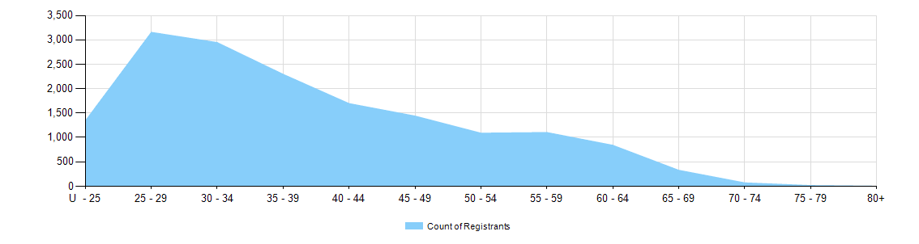

Gender
- Registration type
  - Registration type by gender
Gender | Registration Type | Subtype | ACT | NSW | NT | QLD | SA | TAS | VIC | WA | No PPP | Total
Female | General |  | 173 | 3,461 | 63 | 2,188 | 901 | 225 | 2,540 | 923 | 192 | 10,666
Female | Provisional |  |  | 153 | 7 | 36 | 2 | 2 | 71 | 5 |  | 276
Female | Limited | Supervised practice
Female | Non-practising |  | 7 | 48 | 1 | 18 | 12 | 4 | 55 | 14 | 24 | 183
Total Female |  |  | 180 | 3,662 | 71 | 2,242 | 915 | 231 | 2,666 | 942 | 216 | 11,125
Male | General |  | 90 | 1,669 | 40 | 1,070 | 318 | 97 | 1,241 | 415 | 70 | 5,010
Male | Provisional |  | 4 | 73 | 4 | 22 | 2 | 1 | 29 |  |  | 135
Male | Limited | Supervised practice |  |  |  |  | 1 |  |  |  |  | 1
Male | Non-practising |  |  | 19 |  | 4 | 2 |  | 21 | 3 | 6 | 55
Total Male |  |  | 94 | 1,761 | 44 | 1,096 | 323 | 98 | 1,291 | 418 | 76 | 5,201
Total |  |  | 274 | 5,423 | 115 | 3,338 | 1,238 | 329 | 3,957 | 1,360 | 292 | 16,326

- Percentage
  - Registration by gender percentages
Gender | ACT | NSW | NT | QLD | SA | TAS | VIC | WA | No PPP | Total
Female | 65.7% | 67.5% | 61.7% | 67.2% | 73.9% | 70.2% | 67.4% | 69.3% | 74.0% | 68.1%
Male | 34.3% | 32.5% | 38.3% | 32.8% | 26.1% | 29.8% | 32.6% | 30.7% | 26.0% | 31.9%

