Medical Radiation Practitioner Registration Data: March 2013

Published April 2013

Introduction
The functions of the Medical Radiation Practice Board of Australia include:
- registering medical radiation practitioners and students
- developing standards, codes and guidelines for the Medical Radiation profession
- handling notifications, complaints, investigations and disciplinary hearings
- assessing overseas trained practitioners who wish to practise in Australia
- approving accreditation standards and accredited courses of study.

The Board’s functions are supported by Australian Health Practitioner Regulation Agency (AHPRA). For information about legislation governing our operations see AHPRA's Legislation & Publications at www.ahpra.gov.au/Legislation-and-Publications.aspx

The Board has analysed its registration data and produced a number of statistical reports about registrants to share with the profession and community. The Board will share these statistical reports regularly.

For more information on medical radiation registration, please see the Board’s website:
www.medicalradiationboard.gov.au/Registration.aspx

Index of Tables
Medical radiation practitioners: State and territory by registration type 2
Medical radiation practitioners: Age by registration type 3
Medical radiation practitioners: Gender by state and territory by registration type 4
Medical radiation practitioners: Registration numbers by division by state and territory 4

Medical radiation practitioners: State and territory by registration type
State | General | Limited |  | Non-practising | Provisional | Total | % By State
 |  | Postgraduate training or supervised practice | Public interest
ACT | 211 |  |  | 3 | 8 | 222 | 1.61%
NSW | 4,002 | 1 |  | 25 | 444 | 4,472 | 32.48%
NT | 100 |  |  | 1 | 7 | 108 | 0.78%
QLD | 2,686 |  |  | 1 | 114 | 2,801 | 20.34%
SA | 1,012 |  |  | 7 | 9 | 1,028 | 7.47%
TAS | 274 |  |  | 1 | 13 | 288 | 2.09%
VIC | 3,259 |  | 1 | 96 | 108 | 3,464 | 25.16%
WA | 1,224 |  |  | 3 | 5 | 1,232 | 8.95%
Not Stated | 135 |  |  | 19 |  | 154 | 1.12%
Total | 12,903 | 1 | 1 | 156 | 708 | 13,769

% By state and territory
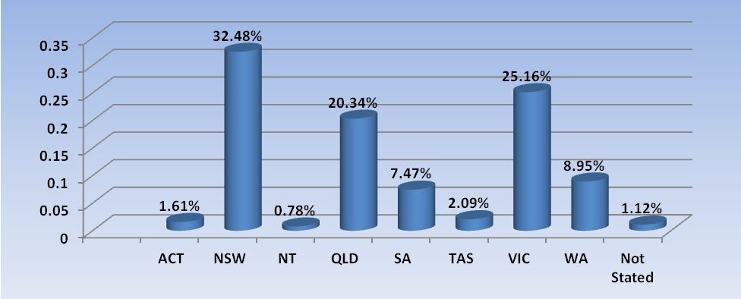

Medical radiation practitioners: Age by registration type
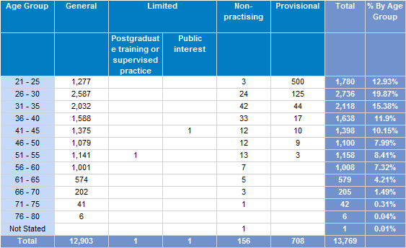
% By age

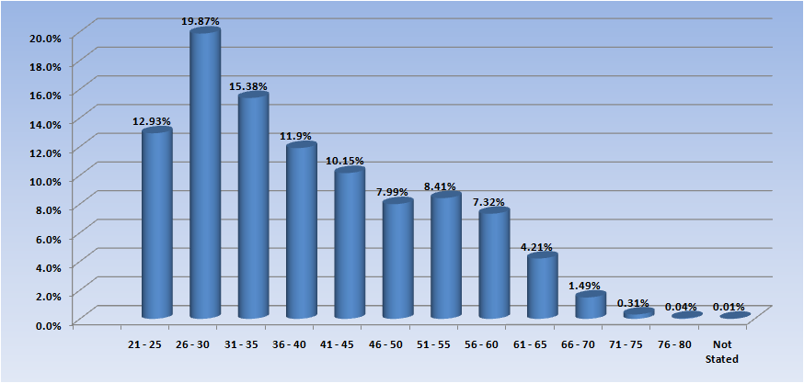

Medical Radiation practitioners: Gender by state and territory by registration type
Sex | State | General | Limited |  | Provisional | Non-practising | Total Count | % By Sex By State
 |  |  | Postgraduate training or supervised practice | Public interest
Female | ACT | 23 |  |  | 4 | 3 | 30 | 0.22%
Female | NSW | 2,644 |  |  | 291 | 21 | 2,956 | 21.47%
Female | NT | 64 |  |  | 3 | 1 | 68 | 0.49%
Female | QLD | 1,780 |  |  | 77 | 1 | 1,858 | 13.49%
Female | SA | 751 |  |  | 6 | 7 | 764 | 5.55%
Female | TAS | 188 |  |  | 9 |  | 197 | 1.43%
Female | VIC | 2,193 |  |  | 67 | 73 | 2,333 | 16.94%
Female | WA | 835 |  |  | 4 | 1 | 840 | 6.1%
Female | Not Stated | 92 |  |  |  | 16 | 108 | 0.78%
Female | Sub total | 8,570 |  |  | 461 | 123 | 9,154 | 66.48%
Male | ACT | 11 |  |  | 2 |  | 13 | 0.09%
Male | NSW | 1,324 | 1 |  | 152 | 4 | 1,481 | 10.76%
Male | NT | 36 |  |  | 4 |  | 40 | 0.29%
Male | QLD | 900 |  |  | 37 |  | 937 | 6.81%
Male | SA | 261 |  |  | 3 |  | 264 | 1.92%
Male | TAS | 86 |  |  | 4 | 1 | 91 | 0.66%
Male | VIC | 1,062 |  | 1 | 41 | 23 | 1,127 | 8.19%
Male | WA | 389 |  |  | 1 | 1 | 391 | 2.84%
Male | Not Stated | 43 |  |  |  | 3 | 46 | 0.33%
Male | Sub total | 4,112 | 1 | 1 | 244 | 32 | 4,390 | 31.88%
Not Stated | ACT | 177 |  |  | 2 |  | 179 | 1.3%
Not Stated | NSW | 34 |  |  | 1 |  | 35 | 0.25%
Not Stated | QLD | 6 |  |  |  |  | 6 | 0.04%
Not Stated | VIC | 4 |  |  |  |  | 4 | 0.03%
Not Stated | WA |  |  |  |  | 1 | 1 | 0.01%
Not Stated | Sub total | 221 |  |  | 3 | 1 | 225 | 1.63%
Total |  | 12,903 | 1 | 1 | 708 | 156 | 13,769

Medical Radiation practitioners: Registration numbers by division by state and territory
 | ACT | NSW | NT | QLD | SA | TAS | VIC | WA | No PPP | Total
Diagnostic Radiographer | 158 | 3,429 | 97 | 2,209 | 823 | 210 | 2,635 | 1,009 | 77 | 10,647
Diagnostic Radiographer and Nuclear Medicine Technologist |  | 1 |  | 11 |  | 1 | 2 | 2 |  | 17
Diagnostic Radiographer and Radiation Therapist |  |  |  | 2 |  |  | 1 |  |  | 3
Nuclear Medicine Technologist | 18 | 365 | 3 | 129 | 69 | 19 | 281 | 67 | 4 | 955
Nuclear Medicine Technologist and Radiation Therapist |  |  |  | 1 |  |  |  |  |  | 1
Radiation Therapist | 53 | 681 | 10 | 444 | 131 | 57 | 587 | 177 | 6 | 2,146
Medical Radiation Practitioner | 229 | 4,476 | 110 | 2,796 | 1,023 | 287 | 3,506 | 1,255 | 87 | 13,769

