

Medical Radiation Practice Board of Australia

Registrant Data

Reporting period: 1 July 2017 – 30 September 2017

Table of contents
Introduction 3
Principal Place of Practice 4
1. Registration Type 4
2. Divisions 5
Age Group 6
3. Registration Type and Sub type 6
4. Divisions 7
Gender 8
5. Registration Type 8
6. Percentage 8

Introduction
The role of the Medical Radiation Practice Board of Australia (the Board) is to:
- register medical radiation practitioners and students
- develop standards, codes and guidelines for the medical radiation profession
- investigate notifications and complaints
- where necessary, conduct panel hearings and refer serious matters to Tribunal hearings
- oversee the assessment of overseas trained practitioners who wish to practise in Australia, and
- approve accreditation standards and accredited courses of study.
The Board’s functions are supported by the Australian Health Practitioner Regulation Agency (AHPRA). For information about legislation governing our operations see About AHPRA at www.ahpra.gov.au/About-AHPRA/What-We-Do/Legislation.aspx.
The Board has analysed its registration data and produced a number of statistical breakdowns about registrants to share with the profession and community. The Board shares these breakdowns regularly.
For more information on medical radiation practitioner registration, please see the Board’s website: www.medicalradiationpracticeboard.gov.au/Registration.aspx

Principal Place of Practice
- Registration Type
  - Registration type and sub type by principal place of practice
Registration Type | Sub Type | ACT | NSW | NT | QLD | SA | TAS | VIC | WA | No PPP | Total
General |  | 254 | 4,960 | 101 | 3,099 | 1,164 | 305 | 3,659 | 1,315 | 241 | 15,098
Provisional |  | 5 | 220 | 4 | 60 | 2 | 1 | 124 | 7 | 1 | 424
Limited | Postgraduate training or supervised practice |  |  |  |  |  |  |  |  | 1 | 1
Non-practising |  | 3 | 55 | 2 | 22 | 15 | 4 | 82 | 19 | 35 | 237
Total |  | 262 | 5,235 | 107 | 3,181 | 1,181 | 310 | 3,865 | 1,341 | 278 | 15,760

  - Registration type by principal place of practice percentages

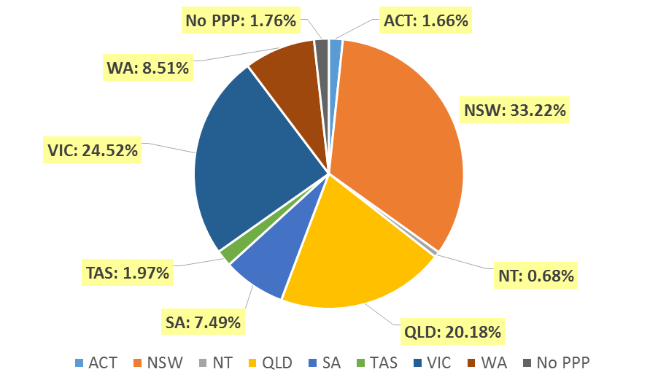

- Divisions
  - By area of division
Divisions | ACT | NSW | NT | QLD | SA | TAS | VIC | WA | No PPP | Total
Diagnostic Radiographer | 181 | 4,004 | 93 | 2,486 | 951 | 233 | 2,902 | 1,096 | 214 | 12,160
Diagnostic Radiographer and Nuclear Medicine Technologist |  | 2 |  | 10 | 1 | 1 | 1 | 1 | 1 | 17
Diagnostic Radiographer and Radiation Therapist |  |  |  | 1 |  |  | 1 |  |  | 2
Nuclear Medicine Technologist | 23 | 443 | 3 | 162 | 79 | 16 | 337 | 67 | 20 | 1,150
Radiation Therapist | 58 | 786 | 11 | 522 | 150 | 60 | 624 | 177 | 43 | 2,431
Total | 262 | 5,235 | 107 | 3,181 | 1,181 | 310 | 3,865 | 1,341 | 278 | 15,760

Age Group
- Registration Type and Sub type
  - Registration by age group
Age Group | General | Provisional | Limited | Non-practising | Total
Age Group | General | Provisional | Post graduate training or supervised practice | Non-practising | Total
U - 25 | 1,066 | 227 |  | 3 | 1,296
25 - 29 | 2,900 | 130 |  | 43 | 3,073
30 - 34 | 2,795 | 28 | 1 | 56 | 2,880
35 - 39 | 2,057 | 24 |  | 36 | 2,117
40 - 44 | 1,615 | 6 |  | 41 | 1,662
45 - 49 | 1,351 | 5 |  | 9 | 1,365
50 - 54 | 1,079 | 3 |  | 13 | 1,095
55 - 59 | 1,073 | 1 |  | 17 | 1,091
60 - 64 | 794 |  |  | 11 | 805
65 - 69 | 300 |  |  | 3 | 303
70 - 74 | 53 |  |  | 4 | 57
75 - 79 | 14 |  |  | 1 | 15
80+ | 1 |  |  |  | 1
Total | 15,098 | 424 | 1 | 237 | 15,760

- Divisions
  - Divisions by age group
Age Group | Diagnostic Radiographer | Diagnostic Radiographer and Nuclear Medicine Technologist | Diagnostic Radiographer and Radiation Therapist | Nuclear Medicine Technologist | Radiation Therapist | Total
U - 25 | 953 |  |  | 132 | 211 | 1,296
25 - 29 | 2,322 | 1 |  | 255 | 495 | 3,073
30 - 34 | 2,088 |  |  | 218 | 574 | 2,880
35 - 39 | 1,566 | 4 |  | 171 | 376 | 2,117
40 - 44 | 1,265 | 3 | 1 | 127 | 266 | 1,662
45 - 49 | 1,077 | 5 | 1 | 96 | 186 | 1,365
50 - 54 | 921 | 2 |  | 57 | 115 | 1,095
55 - 59 | 917 | 2 |  | 40 | 132 | 1,091
60 - 64 | 701 |  |  | 42 | 62 | 805
65 - 69 | 281 |  |  | 9 | 13 | 303
70 - 74 | 54 |  |  | 2 | 1 | 57
75 - 79 | 14 |  |  | 1 |  | 15
80+ | 1 |  |  |  |  | 1
Total | 12,160 | 17 | 2 | 1,150 | 2,431 | 15,760

  - Registration by age group
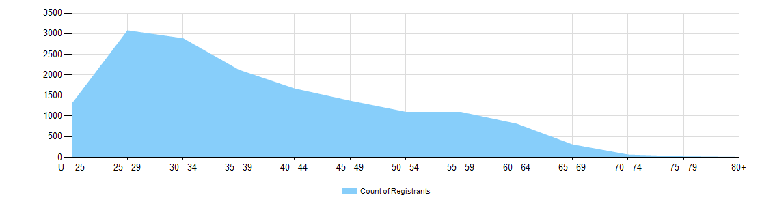

Gender
- Registration Type
  - Registration type by gender
Gender | Registration Type | Sub Type |  | ACT | NSW | NT | QLD | SA | TAS | VIC | WA | No PPP | Total
Female | General |  |  | 169 | 3,339 | 61 | 2,074 | 857 | 210 | 2,447 | 900 | 180 | 10,237
Female | Provisional |  |  | 3 | 154 | 2 | 40 | 1 | 1 | 87 | 6 |  | 294
Female | Limited |  | Postgraduate training or supervised practice |  |  |  |  |  |  |  |  | 1 | 1
Female | Non-practising |  |  | 3 | 40 | 2 | 18 | 14 | 4 | 59 | 13 | 28 | 181
Total Female |  |  |  | 175 | 3,533 | 65 | 2,132 | 872 | 215 | 2,593 | 919 | 209 | 10,713
Male | General |  |  | 85 | 1,621 | 40 | 1,025 | 307 | 95 | 1,212 | 415 | 61 | 4,861
Male | Provisional |  |  | 2 | 66 | 2 | 20 | 1 |  | 37 | 1 | 1 | 130
Male | Limited | Postgraduate training or supervised practice
Male | Non-practising |  |  |  | 15 |  | 4 | 1 |  | 23 | 6 | 7 | 56
Total Male |  |  |  | 87 | 1,702 | 42 | 1,049 | 309 | 95 | 1,272 | 422 | 69 | 5,047
Total |  |  |  | 262 | 5,235 | 107 | 3,181 | 1,181 | 310 | 3,865 | 1,341 | 278 | 15,760

- Percentage
  - Registration by gender percentages
Gender | ACT | NSW | NT | QLD | SA | TAS | VIC | WA | No PPP | Total
Female | 66.8% | 67.5% | 60.7% | 67.0% | 73.8% | 69.4% | 67.1% | 68.5% | 75.2% | 68.0%
Male | 33.2% | 32.5% | 39.3% | 33.0% | 26.2% | 30.6% | 32.9% | 31.5% | 24.8% | 32.0%

