Medical radiation practice registrant data: June 2015
Published August 2015

Introduction
The role of the Medical Radiation Practice Board of Australia (the Board) is to:
- register medical radiation practitioners and students
- develop standards, codes and guidelines for the medical radiation profession
- investigate notifications and complaints
- where necessary, conduct panel hearings and refer serious matters to Tribunal hearings
- oversee the assessment of overseas trained practitioners who wish to practise in Australia, and
approve accreditation standards and accredited courses of study.
The Board’s functions are supported by the Australian Health Practitioner Regulation Agency (AHPRA). For information about legislation governing our operations see About AHPRA at http://www.ahpra.gov.au/About-AHPRA/What-We-Do/Legislation.aspx.
The Board has analysed its registration data and produced a number of statistical breakdowns about registrants to share with the profession and community. The Board shares these breakdowns regularly.
For more information on medical radiation practitioner registration, please see the Board’s website: http://www.medicalradiationpracticeboard.gov.au/Registration.aspx

Contents
Medical radiation practitioners – registration type and sub type by state or territory 3
Medical radiation practitioners – percentage by principal place of practice 3
Medical radiation practitioners – division(s) by state or territory 4
Medical radiation practitioners – registration type and sub type by age group 5
Medical radiation practitioners – by age group 6
Medical radiation practitioners – registration type and sub type by gender 7
Medical radiation practitioners – percentage by gender 8

Medical radiation practitioners – registration type and sub type by state or territory
Medical Radiation practitioners |  |  | Principal place of practice
Registration type | Registration subtype | ACT |  | NSW | NT | QLD | SA | TAS | VIC | WA | No PPP | Total
General |  | 240 |  | 4,542 | 102 | 2,776 | 1,118 | 293 | 3,458 | 1,279 | 176 | 13,984
Provisional |  | 10 |  | 361 | 4 | 137 | 5 | 5 | 100 | 9 | 2 | 633
Limited | Postgraduate training or supervised practice |  |  |  |  |  |  |  | 1 |  |  | 1
 | Public interest
Non-practising |  | 5 |  | 54 | 3 | 25 | 19 | 3 | 98 | 12 | 29 | 248
Total |  | 255 |  | 4,957 | 109 | 2,938 | 1,142 | 301 | 3,657 | 1,300 | 207 | 14,866

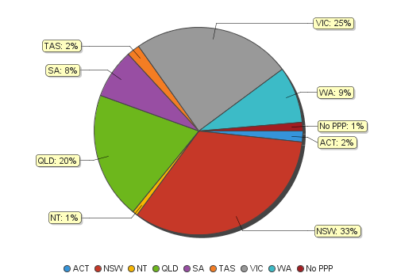
Medical radiation practitioners – percentage by principal place of practice

Medical radiation practitioners – division(s) by state or territory
Medical Radiation practitioners | Principal place of practice
Divisions | ACT | NSW | NT | QLD | SA | TAS | VIC | WA | No PPP | Total
Diagnostic Radiographer | 173 | 3,783 | 97 | 2,330 | 920 | 222 | 2,747 | 1,059 | 165 | 11,496
Diagnostic Radiographer and Nuclear Medicine Technologist |  | 1 |  | 10 | 1 | 1 | 1 | 1 |  | 15
Diagnostic Radiographer and Radiation Therapist |  |  |  | 1 |  |  | 1 |  |  | 2
Nuclear Medicine Technologist | 19 | 425 | 3 | 135 | 71 | 20 | 293 | 65 | 8 | 1,039
Radiation Therapist | 63 | 748 | 9 | 462 | 150 | 58 | 615 | 175 | 34 | 2,314
Total | 255 | 4,957 | 109 | 2,938 | 1,142 | 301 | 3,657 | 1,300 | 207 | 14,866

Medical radiation practitioners – registration type and sub type by age group
Medical radiation practitioners | Registration type/ Sub type
Age group | General | Provisional | Limited |  | Non-practising
 |  |  | Postgraduate training or supervised practice | Public interest |  |  |  | Total
U - 25 | 1,054 | 410 |  |  |  | 10 |  | 1,474
25 - 29 | 2,867 | 143 | 1 |  |  | 48 |  | 3,059
30 - 34 | 2,472 | 45 |  |  |  | 52 |  | 2,569
35 - 39 | 1,707 | 20 |  |  |  | 42 |  | 1,769
40 - 44 | 1,567 | 7 |  |  |  | 32 |  | 1,606
45 - 49 | 1,185 | 5 |  |  |  | 9 |  | 1,199
50 - 54 | 1,057 | 1 |  |  |  | 17 |  | 1,075
55 - 59 | 1,117 | 2 |  |  |  | 19 |  | 1,138
60 - 64 | 646 |  |  |  |  | 10 |  | 656
65 - 69 | 251 |  |  |  |  | 6 |  | 257
70 - 74 | 52 |  |  |  |  | 2 |  | 54
75 - 79 | 9 |  |  |  |  |  |  | 9
80+ |  |  |  |  |  | 1 |  | 1
Total | 13,984 | 633 | 1 |  |  | 248 |  | 14,866

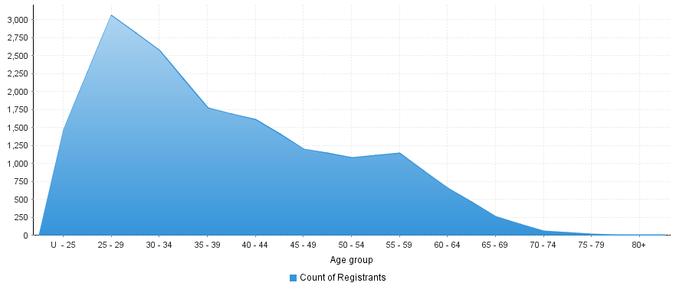
Medical radiation practitioners – by age group
Age Group | U - 25 | 25 - 29 | 30 - 34 | 35 - 39 | 40 - 44 | 45 - 49 | 50 - 54 | 55 - 59 | 60 - 64 | 65 - 69 | 70 - 74 | 75 - 79 | 80+
Count of Registrants | 1,474 | 3,059 | 2,569 | 1,769 | 1,606 | 1,199 | 1,075 | 1,138 | 656 | 257 | 54 | 9 | 1
Medical radiation practitioners – registration type and sub type by gender
Medical radiation practitioners |  |  | Principal place of practice
Gender | Registration type | Registration sub type | ACT | NSW | NT | QLD | SA | TAS | VIC | WA | No PPP | Total
Female | General |  | 153 | 3,036 | 64 | 1,848 | 831 | 199 | 2,319 | 875 | 128 | 9,453
 | Provisional |  | 7 | 242 | 2 | 95 | 2 | 4 | 65 | 8 | 1 | 426
 | Limited | Postgraduate training or supervised practice
 |  | Public interest
 | Non-practising |  | 5 | 38 | 3 | 17 | 19 | 2 | 66 | 10 | 25 | 185
Sub Total |  |  | 165 | 3,316 | 69 | 1,960 | 852 | 205 | 2,450 | 893 | 154 | 10,064
Male | General |  | 87 | 1,506 | 38 | 928 | 287 | 94 | 1,139 | 404 | 48 | 4,531
 | Provisional |  | 3 | 119 | 2 | 42 | 3 | 1 | 35 | 1 | 1 | 207
 | Limited | Postgraduate training or supervised practice |  |  |  |  |  |  | 1 |  |  | 1
 |  | Public interest |  |  |  |  |  |  | 1 |  |  | 1
 | Non-practising |  |  | 16 |  | 8 |  | 1 | 32 | 2 | 4 | 63
Sub Total |  |  | 90 | 1,641 | 40 | 978 | 290 | 96 | 1,207 | 407 | 53 | 4,802
Total |  |  | 255 | 4,957 | 109 | 2,938 | 1,142 | 301 | 3,657 | 1,300 | 207 | 14,866

Medical radiation practitioners – percentage by gender
Medical radiation practitioners | Principal place of practice
Gender | ACT | NSW | NT | QLD | SA | TAS | VIC | WA | No PPP | Total
Female | 64.71% | 66.90% | 63.30% | 66.71% | 74.61% | 68.11% | 66.99% | 68.69% | 74.40% | 67.70%
Male | 35.29% | 33.10% | 36.70% | 33.29% | 25.39% | 31.89% | 33.01% | 31.31% | 25.60% | 32.30%

