Medical Radiation Practice Board of Australia

Registrant Data

Reporting period: December 2015

Table of contents
Introduction 3
Principal Place of Practice 4
1. Registration Type 4
2. Divisions 5
Age Group 6
3. Registration Type and Sub type 6
Gender 7
4. Registration Type 7
5. Percentage 7

Introduction
The role of the Medical Radiation Practice Board of Australia (the Board) is to:
- register medical radiation practitioners and students
- develop standards, codes and guidelines for the medical radiation profession
- investigate notifications and complaints
- where necessary, conduct panel hearings and refer serious matters to Tribunal hearings
- oversee the assessment of overseas trained practitioners who wish to practise in Australia, and
- approve accreditation standards and accredited courses of study.
The Board’s functions are supported by the Australian Health Practitioner Regulation Agency (AHPRA). For information about legislation governing our operations see About AHPRA at http://www.ahpra.gov.au/About-AHPRA/What-We-Do/Legislation.aspx.
The Board has analysed its registration data and produced a number of statistical breakdowns about registrants to share with the profession and community. The Board shares these breakdowns regularly.
For more information on medical radiation practitioner registration, please see the Board’s website: http://www.medicalradiationpracticeboard.gov.au/Registration.aspx

Principal Place of Practice
- Registration Type
  - Registration Type and Sub Type by Principal Place of Practice
Registration Type | Sub Type | ACT | NSW | NT | QLD | SA | TAS | VIC | WA | No PPP | Total
General |  | 249 | 4,656 | 108 | 2,910 | 1,149 | 309 | 3,565 | 1,325 | 220 | 14,491
Provisional |  | 16 | 407 | 11 | 152 | 5 | 6 | 146 | 9 |  | 752
Limited | Postgraduate training or supervised practice |  |  |  |  |  |  | 1 |  |  | 1
Non-practising |  | 6 | 61 | 3 | 24 | 19 | 3 | 101 | 16 | 33 | 266
Total |  | 271 | 5,124 | 122 | 3,086 | 1,173 | 318 | 3,813 | 1,350 | 253 | 15,510

  - Registration Type by Principal Place of Practice Percentages
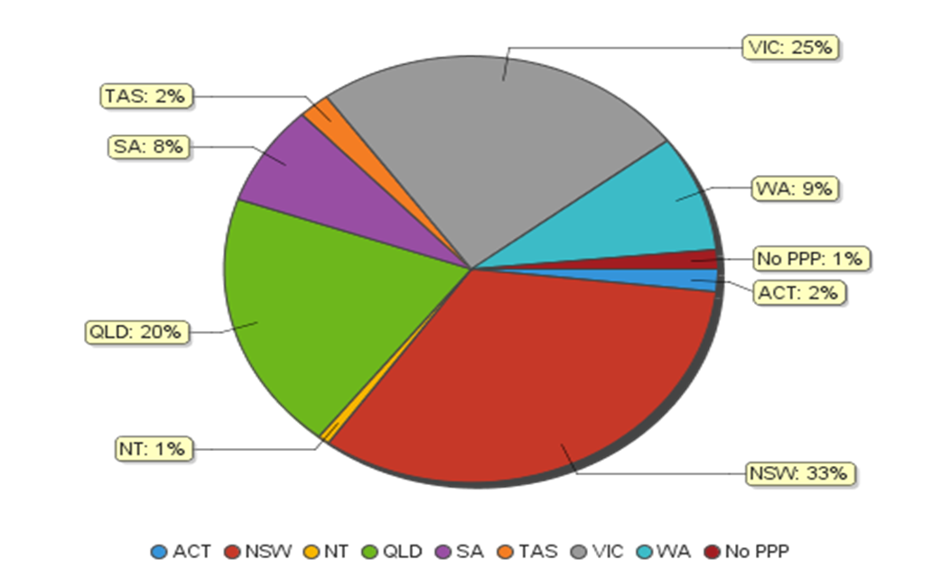

- Divisions
  - By area of Division
Divisions | ACT | NSW | NT | QLD | SA | TAS | VIC | WA | No PPP | Total
Diagnostic Radiographer | 182 | 3,933 | 108 | 2,434 | 947 | 237 | 2,855 | 1,104 | 201 | 12,001
Diagnostic Radiographer and Nuclear Medicine Technologist |  | 1 |  | 10 | 1 | 1 | 1 | 1 |  | 15
Diagnostic Radiographer and Radiation Therapist |  |  |  | 1 |  |  | 1 |  |  | 2
Nuclear Medicine Technologist | 22 | 430 | 3 | 154 | 75 | 20 | 318 | 66 | 10 | 1,098
Radiation Therapist | 67 | 760 | 11 | 487 | 150 | 60 | 638 | 179 | 42 | 2,394
Total | 271 | 5,124 | 122 | 3,086 | 1,173 | 318 | 3,813 | 1,350 | 253 | 15,510

Age Group
- Registration Type and Sub type
  - Registration by Age Group
Age Group | General | Provisional | Limited | Non-practising | Total
 |  |  | Post graduate training or supervised practice
U - 25 | 1,090 | 521 |  | 8 | 1,619
25 - 29 | 2,943 | 146 | 1 | 46 | 3,136
30 - 34 | 2,595 | 48 |  | 61 | 2,704
35 - 39 | 1,811 | 18 |  | 48 | 1,877
40 - 44 | 1,603 | 14 |  | 35 | 1,652
45 - 49 | 1,194 | 3 |  | 10 | 1,207
50 - 54 | 1,080 | 2 |  | 16 | 1,098
55 - 59 | 1,119 |  |  | 20 | 1,139
60 - 64 | 702 |  |  | 12 | 714
65 - 69 | 279 |  |  | 6 | 285
70 - 74 | 58 |  |  | 3 | 61
75 - 79 | 17 |  |  | 1 | 18
Total | 14,491 | 752 | 1 | 266 | 15,510

  - Registration by Age Group

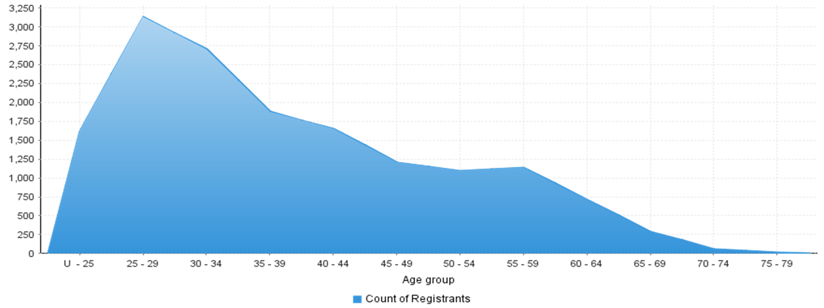

Gender
- Registration Type
  - Registration type by gender
Gender | Registration Type | Sub Type | ACT | NSW | NT | QLD | SA | TAS | VIC | WA | No PPP | Total
Female | General |  | 161 | 3,117 | 68 | 1,953 | 848 | 213 | 2,385 | 910 | 160 | 9,815
 | Provisional |  | 14 | 277 | 7 | 110 | 2 | 5 | 87 | 7 |  | 509
 | Non-practising |  | 6 | 44 | 3 | 16 | 19 | 3 | 71 | 14 | 26 | 202
Total Female |  |  | 181 | 3,438 | 78 | 2,079 | 869 | 221 | 2,543 | 931 | 186 | 10,526
Male | General |  | 88 | 1,539 | 40 | 957 | 301 | 96 | 1,180 | 415 | 60 | 4,676
 | Provisional |  | 2 | 130 | 4 | 42 | 3 | 1 | 59 | 2 |  | 243
 | Limited | Postgraduate training or supervised practice |  |  |  |  |  |  | 1 |  |  | 1
 | Non-practising |  |  | 17 |  | 8 |  |  | 30 | 2 | 7 | 64
Total Male |  |  | 90 | 1,686 | 44 | 1,007 | 304 | 97 | 1,270 | 419 | 67 | 4,984
Total |  |  | 271 | 5,124 | 122 | 3,086 | 1,173 | 318 | 3,813 | 1,350 | 253 | 15,510

- Percentage
  - Registration by Gender Percentages
Gender | ACT | NSW | NT | QLD | SA | TAS | VIC | WA | No PPP | Total
Female | 66.79% | 67.10% | 63.93% | 67.37% | 74.08% | 69.50% | 66.69% | 68.96% | 73.52% | 67.87%
Male | 33.21% | 32.90% | 36.07% | 32.63% | 25.92% | 30.50% | 33.31% | 31.04% | 26.48% | 32.13%

